On devices running **iOS 16 and above**, you will need to enable a special OS-level Developer Mode for **internal builds** testing. One time for all dev apps.

If the app shows the below error. Follow steps mentioned in document.

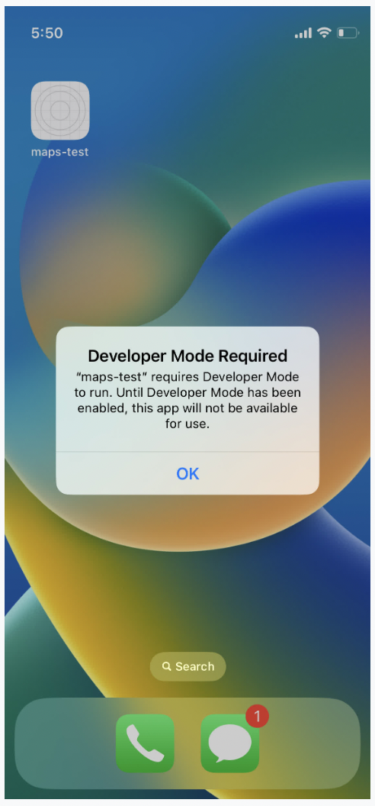

1. Click on **Settings app**, navigate to **Privacy & Security > Developer Mode.**

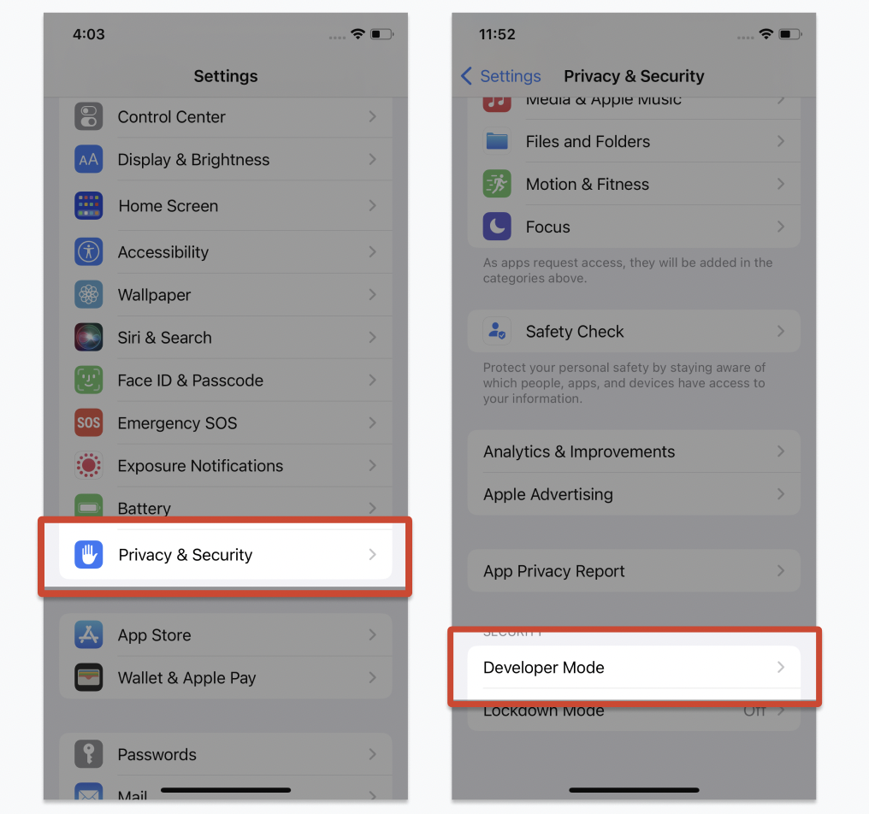

1. **Make Toggle ON.** You will receive a prompt from iOS to **restart** your device. Press **Restart** to do so.

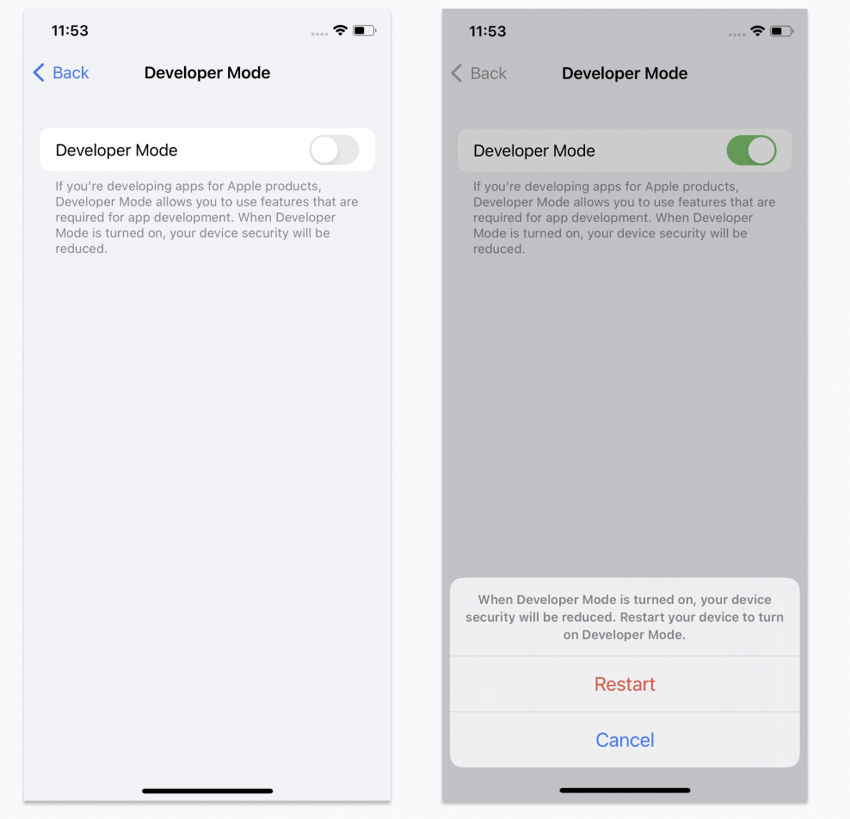

1. After the device restarts, unlock your device; a system alert should appear. Press **Turn On** and then, when prompted, enter your passcode.

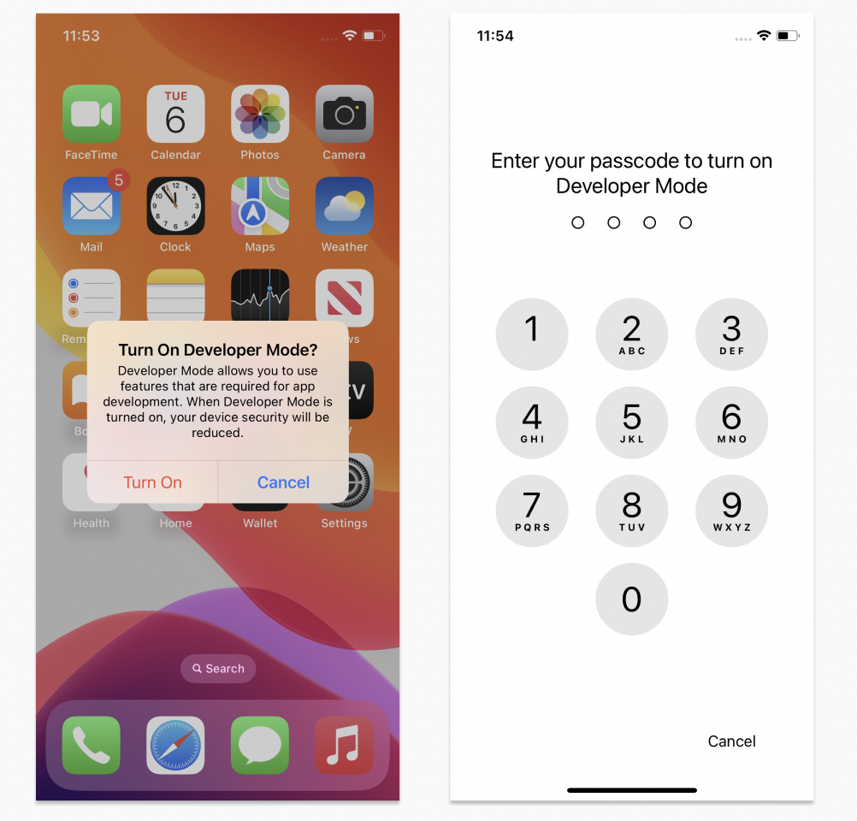  
  
For more info follow below link  
<https://docs.expo.dev/guides/ios-developer-mode/>  
<https://developer.apple.com/documentation/xcode/enabling-developer-mode-on-a-device>